Artefact Designs

This section will contain the group’s initial concept designs for the product:

## Low Fidelity Designs:

The low fidelity designs show an early concept art of the characters, interfaces and items that will be later improved and implemented in the final product:

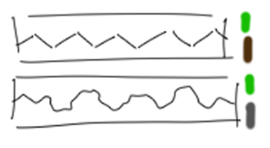 **Game Background**

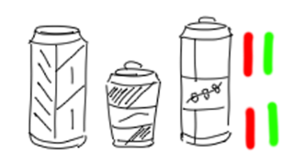 **Energy Drinks**

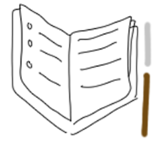 **Diary**

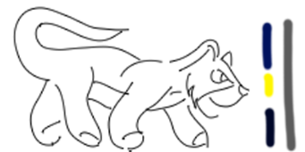 **Enemy**

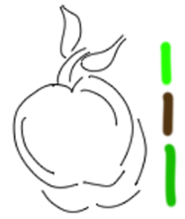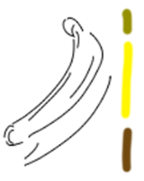 **Ingredients**

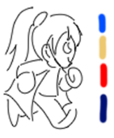 **Character Running**

## High Fidelity Designs

The high fidelity designs show a more advanced concept art of the characters, interfaces and items that should be implemented in the final product:

 **Game Background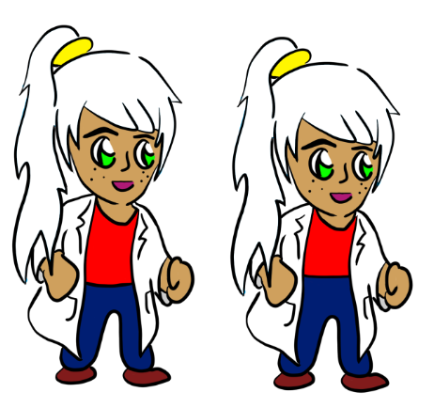 Character Idle**

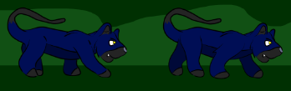 **Enemy Running**

 **Ingredients**

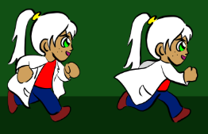 **White Hair**

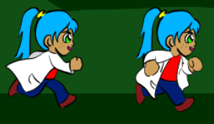 **Blue Hair**

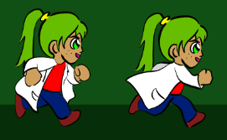 **Green Hair**

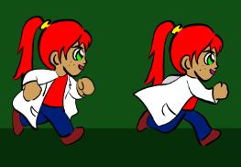 **Red Hair**

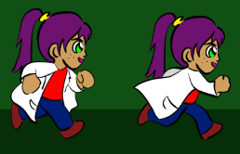 **Purple Hair**

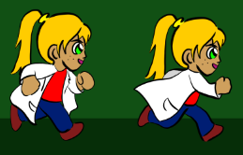 **Yellow Hair**

Storyboard

The following storyboard shows the start of the game. Title: Start of Game Cutscene

|  |
| --- |
| * **Scene:** 01 * **Shot:** 01 * **Description:** This is the Start Screen of the game where the Start Game, Load Game, Settings and Quit Game buttons will be. * **Dialogue:** None. * **Sound:** Background music. |
| * **Scene:** 01 * **Shot:** 02 * **Description:** When the Start button is pressed, a plane goes through the sky from the right side of the screen to the left side of the screen. * **Dialogue:** None. * **Sound:** Plane flying through the sky. |
| * **Scene:** 01 * **Shot:** 03 * **Description:** For a few seconds there will be nothing on the screen, but the player will be able to hear the plane landing. * **Dialogue:** None. * **Sound:** Sound of the plane landing. |
| * **Scene:** 01 * **Shot:** 04 * **Description:** The scientist will enter the screen from the left side of the screen and will start giving exposition to the players. * **Dialogue:** Exposition: “Huh, after that long journey I’m finally in the jungle! I can start my research on different flavours of the energy drinks” * **Sound:** Background music. |
| * **Scene:** 01 * **Shot:** 05 * **Description:** After the exposition, a “How to Play” screen will appear to teach the player how to control the character. * **Dialogue:** None. * **Sound:** Background music. |
| * **Scene:** 01 * **Shot:** 06 * **Description:** After that, the player will be able to move to the right of the screen entering a trigger zone (the warp for the next stage) and the introduction of the game will conclude. * **Dialogue:** None. * **Sound:** Background music, Jump sound effect. |

## Level Design

Here are the early concepts of the level design, the game will be composed of two levels and each level will have three stages.

The first stage will be mostly played out in the jungle, as the player reaches the end of the stage, he will enter the second stage that takes place in a cave. The designs for the stages will intertwine with the story and create a suitable game world.

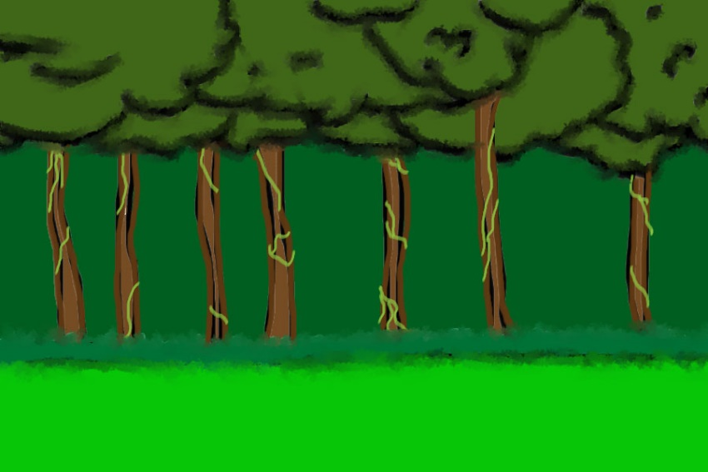 **Jungle Level Design Concept**

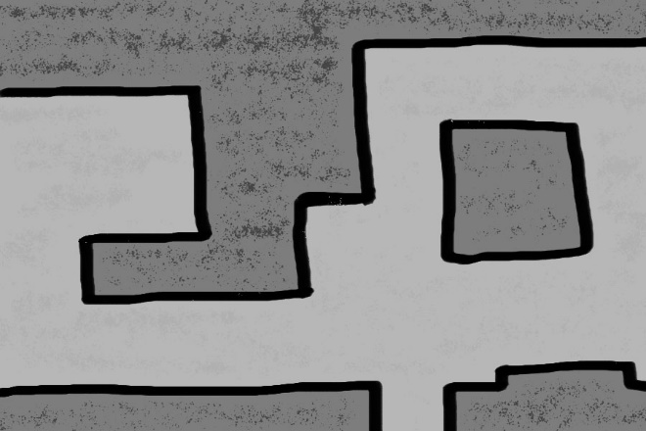 **Cave Level Design Concept**

## Prototype

The following link contains a prototype of how the start of the game will play out, InVision (InVisionApp Inc., 2011) was used to create it.

<https://projects.invisionapp.com/share/2BP9OQH4EMG#/screens>

## Evaluation

The heuristics evaluation can be found in the following link:

**LINK FOR THE WIKI GOES HERE**

Summary goes here